Project 2 Part B_1 Template

This is just a template to help you understand what are the things you need to include in your Submission today. Do not copy paste exact screenshots or calculation values or equations from this file when you submit the assignment. Use values given in the pdf.

1. Provide a graph of the dynamic instruction count for at least 5 sentences of varying length for Project 2 Part A_2 Unoptimized Code.
   1. Mention your Sentence 1 choice.

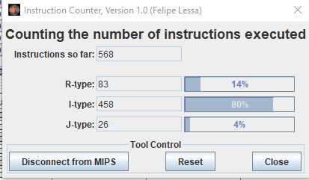

* 1. Mention your Sentence 2 choice.

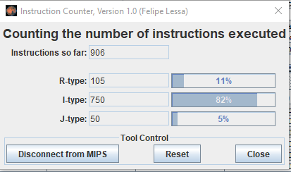

* 1. Mention your Sentence 3 choice.

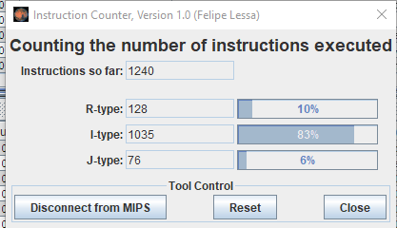

* 1. Mention your Sentence 4 choice.

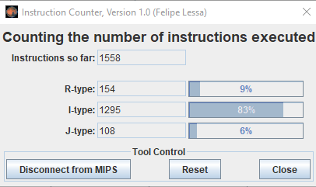

* 1. Mention your Sentence 5 choice.

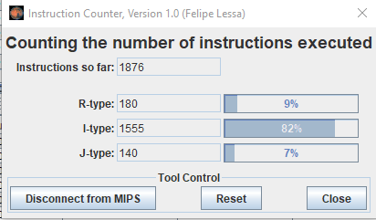

* 1. Graph of dynamic instruction count for sentences of 10, 20, 30, 40, and 50 characters in length for the 5 different sentences. (The char counts would be those of your particular sentence choices)

1. Provide calculations for the CPI of the above 5 sentences as well as a graph of their respective CPIs for Project 2 Part A_2 Unoptimized Code.
   1. CPI Calculations for Sentences 1,2, 3, 4 and 5.
 $\frac{\left(\left(4×83\right)+\left(2×458\right)+\left(1×26\right)\right)}{568}=2.243$

     1. Also similarly calculate for sentence 2
      2. Also similarly calculate for sentence 3
      3. Also similarly calculate for sentence 4
      4. Also similarly calculate for sentence 5
   2. Plot Graph of CPI for Sentences 1,2, 3, 4 and 5.
2. Calculate and plot a graph of Energy consumption for 5 different sentences of different lengths prior to optimization assuming ALU = A fj, Jump = B fj, Branch = C fj, Memory = D fj, and Other = E fj. (Use values given in PDF to find the energy consumption)
   1. Calculations of Energy Consumption for Sentences 1,2, 3, 4 and 5.

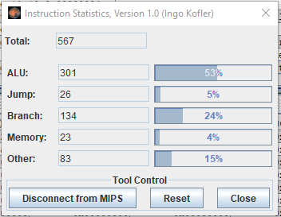

* + 1. Similarly, show calculation steps for Sentence 2.

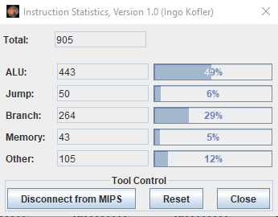

* + 1. Similarly, show calculation steps for Sentence 3.

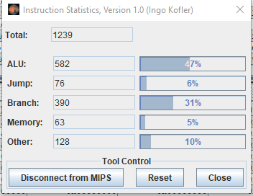

* + 1. Similarly, show calculation steps for Sentence 4.

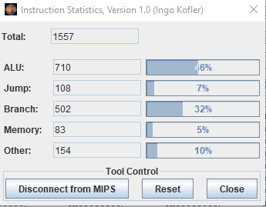

* + 1. Similarly, show calculation steps for Sentence 5.

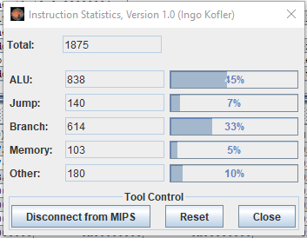

* 1. Graph of Energy Consumption for Sentences 1,2, 3, 4 and 5 of 10, 20, 30, 40, and 50 characters in length. (The char counts would be those of your particular sentence choices)